|  |  |  |  |  |
| --- | --- | --- | --- | --- |
| Produto | Designação | Preço Unitário | Qtd. | Total |
| C:\Users\Célio Garcia\BCCL\Capas Ipad3\150 (1).jpg | **Diamond Pattern Stand PU Leather Case new iPad/iPad2** | 39.63 USD  3.963,00 AKZ | 10 | 396.28 USD  39.628,00 AKZ |
| 25.85 USD  2.585,00 AKZ | 30 | 775,48 USD  77.548,00 AKZ |
| 29.23 USD  2.923,00 AKZ | 50 | 1. 461,58 USD  146.580,00 AKZ |
| C:\Users\Célio Garcia\BCCL\Capas Ipad3\150 (2).jpg | **Rotatable 360 Angle With Lichee Pattern Three Visual Angle Stand PU Leather Case for New iPad/ipad2** | 36.94 USD  3.694,00 AKZ | 10 | 369.38 USD  36.938,00 AKZ |
| 18.49 USD  1.849,00 AKZ | 30 | 554.93 USD  55.493,00 AKZ |
| 25.45 USD  2.545,00 AKZ | 50 | 1.272,55 USD  127.255,00 AKZ |
| C:\Users\Célio Garcia\BCCL\Capas Ipad3\150 (3).jpg | **Rotatable 360 Angle With Point Pattern Three Visual Angle Stand PU Leather Case for New iPad/ipad2** | 37.94 USD  3.794,00 AKZ | 10 | 379.38 USD  37.938,00 AKZ |
| 18.83 USD  1.883,00 AKZ | 30 | 564.93 USD  56.493,00 AKZ |
| 25.66 USD  2.566,00 AKZ | 50 | 1282,55 USD  128.255,00 AKZ |
|  | **Woodiness Stand Capa para o novo iPad/iPad3 - Grey** | 36.86 USD  3.686,00 AKZ | 10 | 368.61 USD  36.861,00 AKZ |
| 20.97 USD  2.097,00 AKZ | 30 | 629.12 USD  62.912,00 AKZ |
| 19.13 USD  1.913,00 AKZ | 50 | 956,79 USD  95.679,00 AKZ |
|  | **Woodiness Stand Capa para o novo iPad/iPad3 - Brown** | 36.86 USD  3.686,00 AKZ | 10 | 368.61 USD  36.861,00 AKZ |
| 20.97 USD  2.097,00 AKZ | 30 | 629.12 USD  62.912,00 AKZ |
| 19.13 USD  1.913,00 AKZ | 50 | 956,79 USD  95.679,00 AKZ |
|  | **Three-fold With Point Pattern Stand capa para o novo iPad/iPad3 - Pink** | 33.71 USD  3.371,00 AKZ | 10 | 337.10 USD  33.710,00 AKZ |
| 18.20 USD  1.820,00 AKZ | 30 | 545.86 USD  54.586,00 AKZ |
| 16.25 USD  1.625,00 AKZ | 50 | 812.62 USD  81.262,00 AKZ |
|  | **Sunflower Pattern Stand Case For New iPad/iPad2** | 43.58 USD  4.358,00 AKZ | 10 | 430,58 USD  43.058,00 AKZ |
| 31.41 USD  3.141,00 AKZ | 30 | 942.54 USD  94.254,00 AKZ |
| 24.75 USD  2.475,00 AKZ | 50 | 1.237,80 USD  123.780,00 AKZ |
| C:\Users\Célio Garcia\BCCL\Capas Ipad3\150.jpg | **Map Pattern With Multi Visual Angle Stand PU Leather Case iPad/iPad2** | 41.58 USD  4.158,00 AKZ | 10 | 410,58 USD  41.058,00 AKZ |
| 30.75 USD  3.075,00 AKZ | 30 | 922.54 USD  92.254,00 AKZ |
| 20.75 USD  2.075,00 AKZ | 50 | 1.037,80 USD  103.780,00 AKZ |
| C:\Users\Célio Garcia\BCCL\Capas Ipad3\1.jpg | **Grid Pattern Wallet /Hangbag Leather**  **New iPad3/iPad2** | 38.54 USD  3.854,00 AKZ | 10 | 385.38 USD  38.538,00 AKZ |
| 21.30 USD  2.130,00 AKZ | 30 | 639.12 USD  63.912,00 AKZ |
| 19.63 USD  1.963,00 AKZ | 50 | 981.50 USD  98.150,00 AKZ |
| C:\Users\Célio Garcia\BCCL\Capas Ipad3\2006\3_496.jpg | **Butterfly Pattern Envelope With Three Visual Angle And Sleep Function Stand PU Leather Case for New iPad/iPad2 - Brown** | 39.58 USD  3.958,00 AKZ | 10 | 390,58 USD  39.058,00 AKZ |
| 30.41 USD  3.041,00 AKZ | 30 | 912.54 USD  91.254,00 AKZ |
| 19.96 USD  1.996,00 AKZ | 50 | 997,80 USD  99.780,00 AKZ |
| C:\Users\Célio Garcia\BCCL\Capas Ipad3\2.jpg | **Banck Card Holder & Three Visual Angle Handbag Stand PU Leather Case for New iPad/ipad2** | 46.58 USD  4.658,00 AKZ | 10 | 460,58 USD  46.058,00 AKZ |
| 32.41 USD  3.241,00 AKZ | 30 | 972.54 USD  97.254,00 AKZ |
| 30.76 USD  3.076,00 AKZ | 50 | 1.537,80 USD  153.780,00 AKZ |
|  | **Handbag Stand Capa para o novo iPad/iPad3 - Leopard** | 37.40 USD  3.740,00 AKZ | 10 | 375.38 USD  37.538,00 AKZ |
| 20.97 USD  2.097,00 AKZ | 30 | 629.12 USD  62.912,00 AKZ |
| 19.43 USD  1.943,00 AKZ | 50 | 971.50 USD  97.150,00 AKZ |

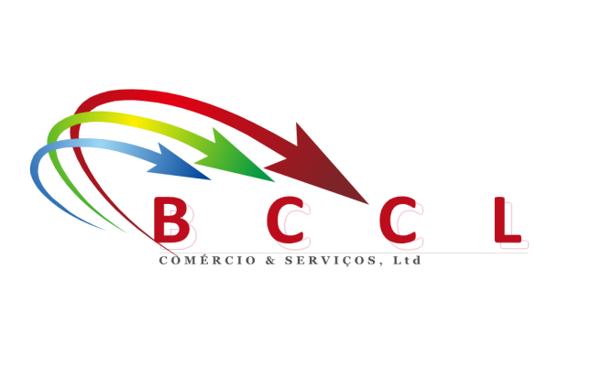

**BCCL – COMÉRCIO & SERVIÇOS, LDA**

**Departamento de Informática**

**Telefones: (+244) 921785735 / (+244) 923501888 / (+244) 923336431 / (+244) 923408033**

**E-mail:** [**informatica@bccl-ao.com**](mailto:informatica@bccl-ao.com)

**Geral:** [**bccl@bccl-ao.com**](file:///C:\Users\Célio%20Garcia\AppData\Roaming\Microsoft\Word\bccl@bccl-ao.com)

**Web Site:** [**www.bccl-ao.com**](http://www.bccl-ao.com)